**Assignment No:-72**

Name:-Suryawanshi Sangramsingh Sambhaji

Batch: - Delta - DCA (Java) 2024 Date:-8/9/2024

Write a query to insert multiple documents into a collection in MongoDB.

db.std.insertMany([

{ name: "Alice", age: 30 },

{ name: "Bob", age: 25 },

{ name: "Charlie", age: 35 }

]);

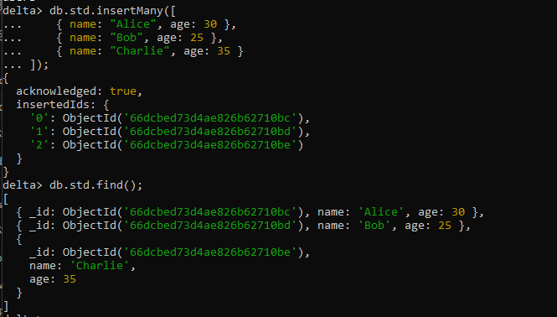

Write a query to find all documents in a collection where the age field is greater than 25.

db.std.find({ age: { $gt: 25 } });

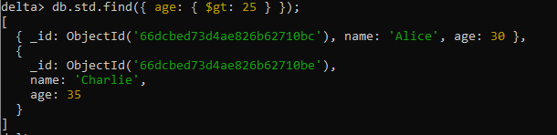

How would you update multiple documents in a MongoDB collection to set a new field status to "active"?

db.std.updateMany(

{},

{ $set: { status: "active" } }

);

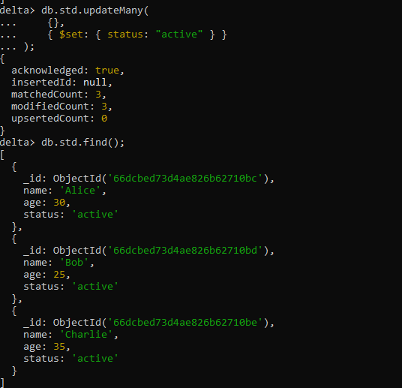

Write a query to delete documents from a MongoDB collection where the isActive field is false.

db.std.deleteMany({ isActive: false });



How would you create a unique index on the email field of a collection?

db.std.createIndex({ email: 1 }, { unique: true });

Write a query to sort documents by the createdAt field in descending order.

db.std.find().sort({ createdAt: -1 });

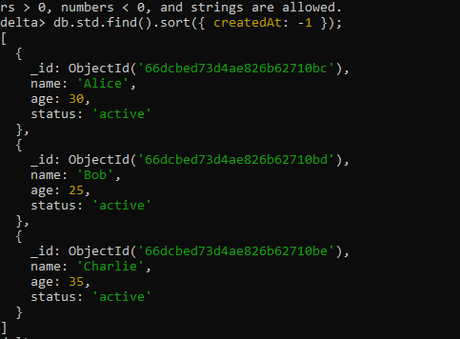

Write a MongoDB aggregation query to group documents by the category field and calculate the average price for each category.

db.std.aggregate([ { $group: { _id: "$category", averagePrice: { $avg: "$price" } } } ]);



How would you perform a text search in MongoDB for documents containing the word "MongoDB"?

db.std.createIndex({ fieldName: "text" });



Write a query to update the first document that matches the name field as "John" and increment the age by 1.

db.std.find({ $text: { $search: "MongoDB" } });

Write a query to fetch documents where the tags field contains both "mongodb" and "database".

db.std.find({

tags: { $all: ["mongodb", "database"] }

});

